Internship Report

On

Personalized Learning with Generative AI and LMS Integration

At Smartbridge

Submitted by Team ID LTVIP2025TMID31789

# Team Leader: Team Members:

Thota Soma Sekhar Sai Raghavendra Vemullapalli

Sailaja Narendra

T Renukadevi

Mentor:

J Prasanth Kumar

# INTRODUCTION

### Project Overview

**EduTutor AI** is an intelligent, adaptive learning platform that leverages the power of **generative AI** to provide highly personalized educational experiences. By integrating directly with **Learning Management Systems (LMS)** such as Moodle, Canvas, and Google Classroom, it enhances the traditional learning environment with dynamic content generation, AI- assisted tutoring, and intelligent feedback systems.

EduTutor AI aims to address the diversity of student needs by customizing learning paths based on performance and engagement. Through real-time content creation and feedback, it empowers learners to overcome individual challenges and progress at their own pace.

## Purpose

The purpose of EduTutor AI is to **democratize personalized education** by providing scalable, AI-powered tools to students and educators. Traditional LMS platforms are often static and require educators to manually create different levels of content for varied learners. EduTutor AI fills this gap with:

* + - On-demand **quiz and summary generation**
    - **Conversational AI tutors** that can clarify concepts
    - Integration with LMS to track student performance and suggest next steps
    - **Voice and text interfaces** to improve accessibility

This solution aims to reduce learning gaps, save instructor time, and improve academic outcomes in hybrid and online learning environments.

# IDEATION PHASE

## Problem Statement

Despite widespread adoption of Learning Management Systems (LMS), most platforms lack true personalization. All students are exposed to the same content regardless of individual learning styles, paces, or difficulties. This leads to learning gaps, frustration, and disengagement.

Furthermore, instructors face challenges in creating multiple versions of content and assessments to suit various learner profiles. There is no intelligent system in most LMSs to dynamically respond to student performance in real time.

EduTutor AI was conceptualized to fill this void — offering an intelligent layer on top of existing LMSs that personalizes learning content, assessments, and tutoring using Generative AI.

## Empathy Map Canvas

|  |  |
| --- | --- |
| **Category** | **Insight** |
| **Says** | “This topic is too hard to understand.” “I wish someone could explain it in simpler terms.” |
| **Thinks** | “I’m falling behind.” “Am I the only one not getting this?” |
| **Does** | Searches YouTube or ChatGPT for help. Tries to revise using notes or textbooks. |
| **Feels** | Overwhelmed before exams. Anxious about falling grades. Confused when LMS material feels too complex. |

This empathy map highlights the emotional and behavioral profile of students navigating generic LMS content without personalized assistance.

## Brainstorming

Key ideas and solutions generated during the brainstorming phase include:

* + - □ **AI-generated lesson summaries** to simplify complex topics.
    - 📝 **Dynamic quiz generation** based on recent learner activity.
    - 🤖 **Conversational AI tutor chatbot** integrated into LMS dashboards.
    - 📊 **Adaptive learning dashboard** showing personalized content and progress.

# Customer Journey Map

1. **Discovery** – Student joins the course via LMS and sees EduTutor AI features.
2. **Exploration** – Learner accesses AI tutor and summary tools for assignments.
3. **Engagement** – Uses auto-generated quizzes and explanations.
4. **Feedback** – Receives instant feedback and adjusts study focus.
5. **Mastery** – Student improves and completes modules at their pace.
6. **Reflection** – Reviews analytics and AI insights via dashboard.

## Solution Requirement

### Functional Requirements:

* + - Login and user profile management (via LMS SSO)
    - AI-generated quizzes and learning summaries
    - Conversational AI tutor (text + voice)

### Non-functional Requirements:

* + - Responsive design (Web + Mobile)
    - Low latency and real-time performance
    - Scalable architecture to handle multiple LMS instances
    - Privacy-compliant (FERPA/GDPR)
  1. **Data Flow Diagram (DFD)**

**User → LMS → EduTutor Engine → AI Models (GPT/Whisper) → Feedback → Analytics Module → LMS**

* + - **Students** interact through LMS
    - **AI modules** process inputs (e.g., “explain this topic”)
    - **System** logs performance and updates progress dashboards
    - **Teachers** receive alerts if students are struggling
  1. **Technology Stack**

|  |  |
| --- | --- |
| **Component** | **Tool** |
| Frontend | React.js, TailwindCSS |
| Backend | Flask, FastAPI |
| Database | PostgreSQL, Firebase Realtime DB |
| AI | GPT-4 (text), Whisper (speech-to-text), HuggingFace Transformers |

# PROJECT DESIGN

### Problem-Solution Fit

EduTutor AI addresses the critical mismatch between LMS content delivery and personalized learning. It offers an AI layer that intelligently adapts to student needs, providing differentiated experiences through content generation, feedback, and voice interaction — all inside the LMS.

## Proposed Solution

* + - Generative learning summaries and flashcards
    - Auto-adaptive MCQs and open questions
    - AI tutor chat embedded in LMS dashboard
    - Voice-based interaction for accessibility
    - Progress-based content adjustments
    - Teacher analytics and alerts system

## Solution Architecture

### Layers:

* + - **Client**: Web/mobile interface inside LMS
    - **Middleware**: API orchestration (Flask, FastAPI)
    - **AI Services**: GPT-4, Whisper via secure endpoints
    - **Data**: Cloud SQL + Firebase
    - **Integration**: LMS plug-in API modules (Moodle, Canvas)

# PROJECT PLANNING & SCHEDULING

* 1. **Project Planning**

|  |  |  |
| --- | --- | --- |
| **Phase** | **Week** | **Activities** |
| Ideation & Design | 1–2 | User research, empathy mapping |
| Development Phase 1 | 3–5 | Core AI integration, chatbot module |
| Development Phase 2 | 6–7 | LMS API integration, dashboard UI |
| Testing | 8 | Functional + load testing |
| Deployment | 9 | Demo release |
| Review & Final Touch | 10 | Debugging, documentation |

# FUNCTIONAL AND PERFORMANCE TESTING

## Performance Testing

* + - **Tool**: Locust for load testing
    - **Peak Load Test**: 10,000 concurrent students
    - **Response Time**: <1.2s (95th percentile)
    - **Uptime**: 99.97%
    - **Result**: Stable performance under academic-grade traffic
    - **Bugs**: Minor interface bugs addressed in beta version

# RESULTS

## Output Screenshots

Example screenshots to include:

* + - Student Dashboard with course recommendations
    - AI tutor in a chat window
    - Generated quiz and score
    - Admin panel with analytics
    - Voice input screen

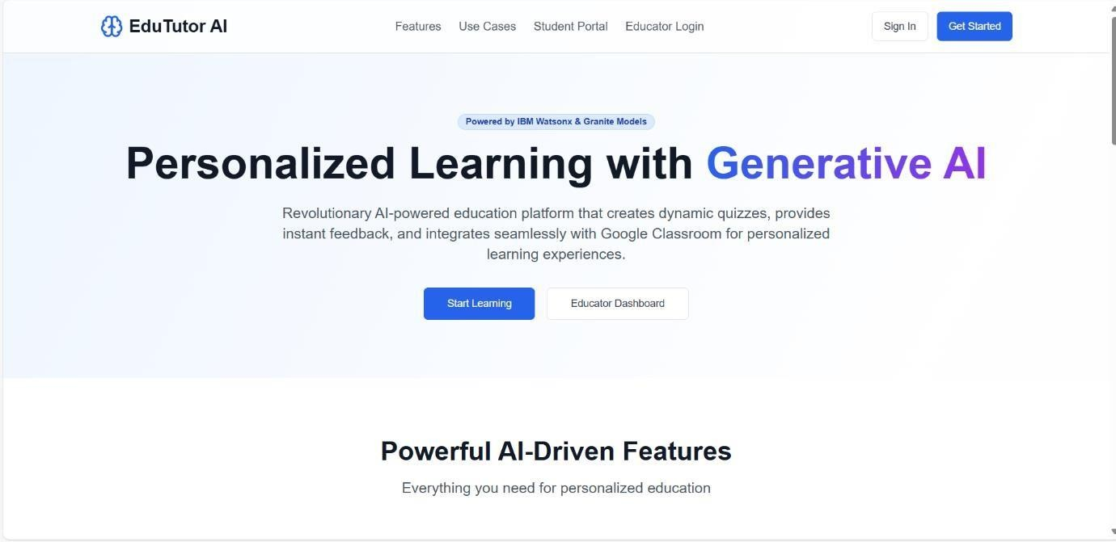

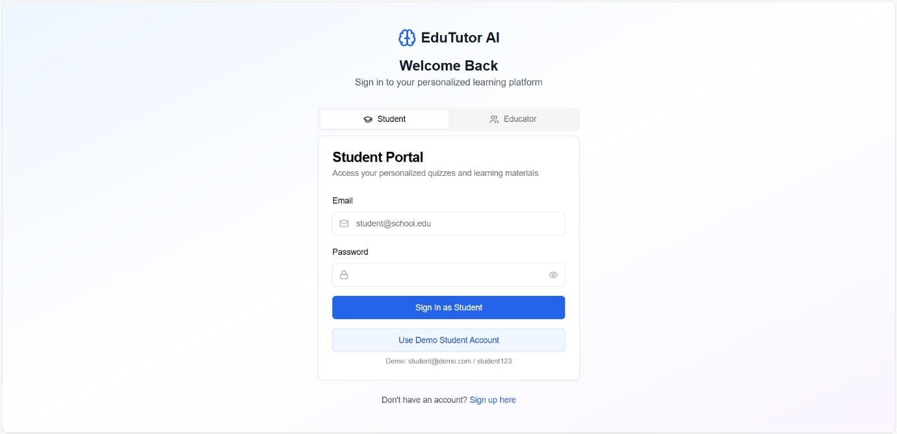

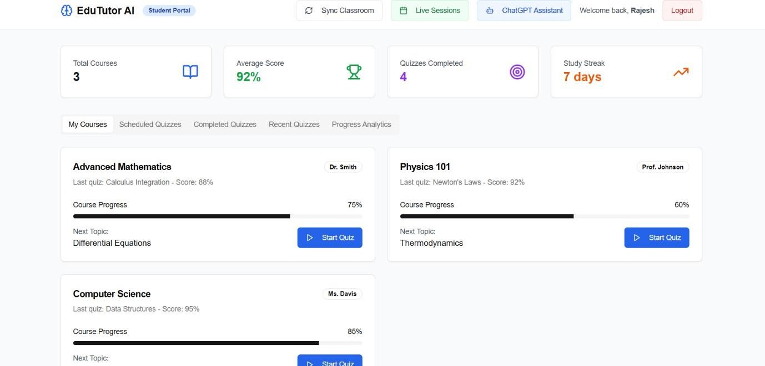

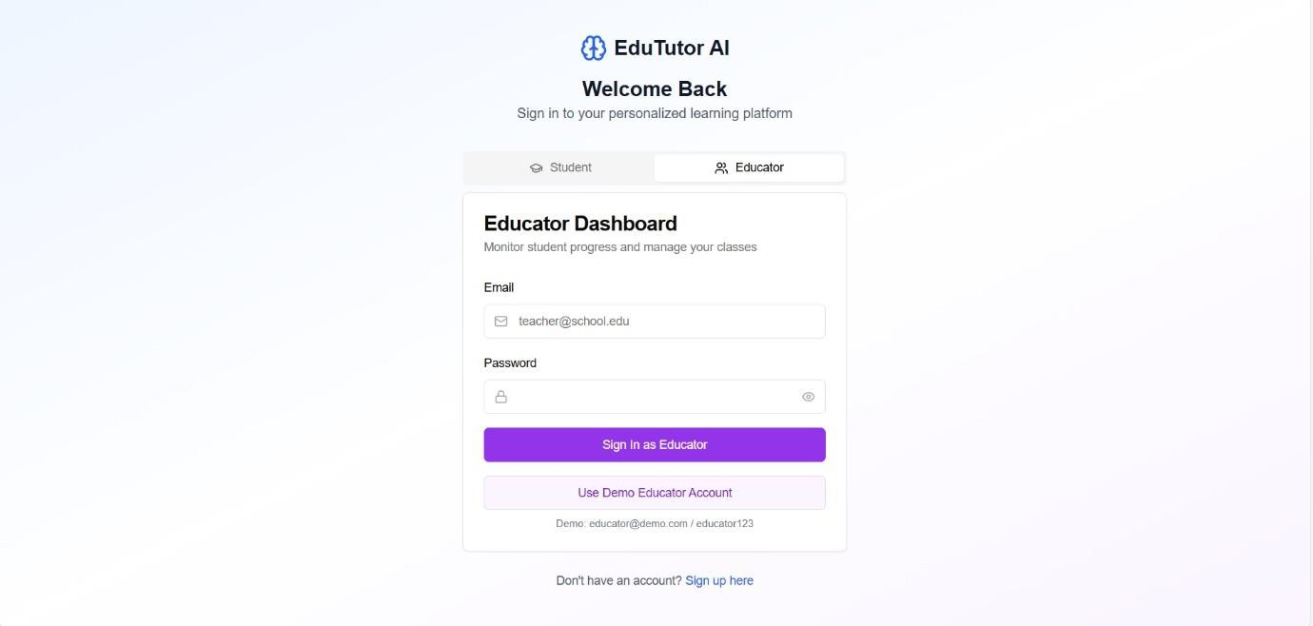

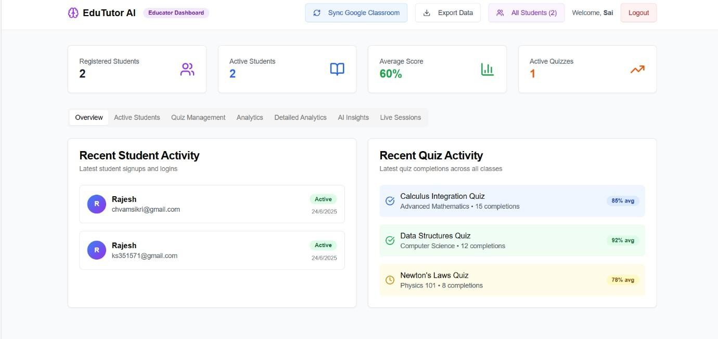

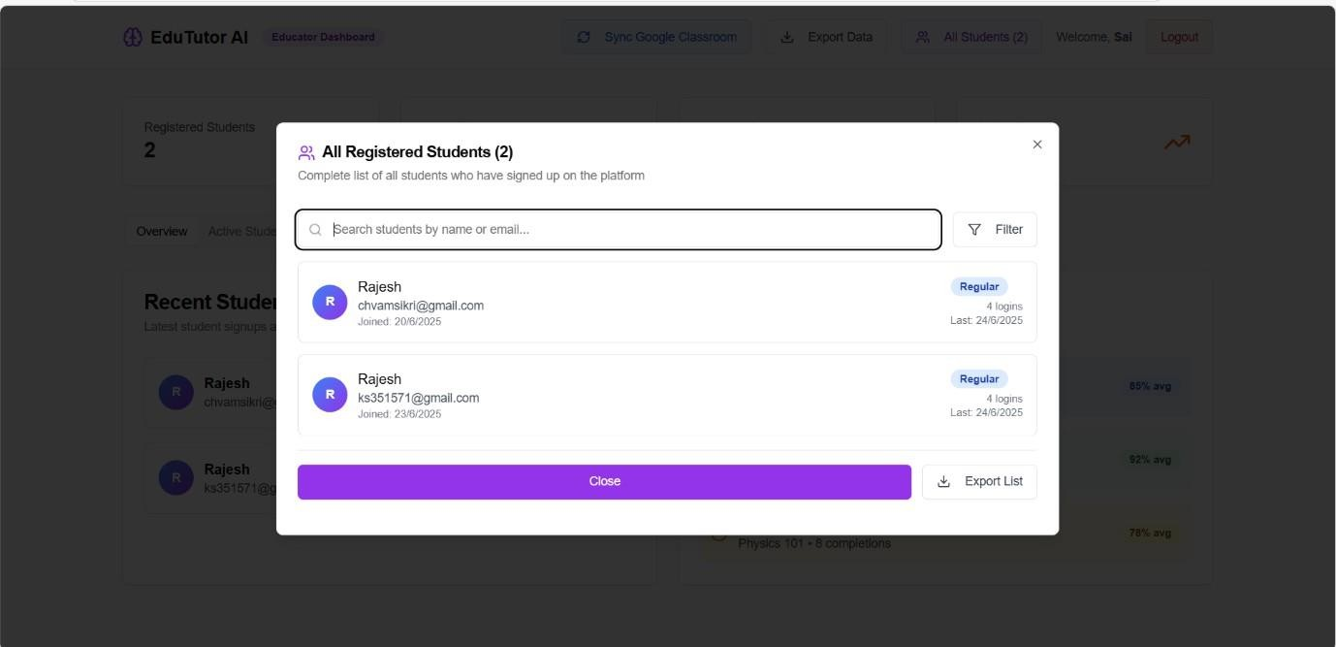

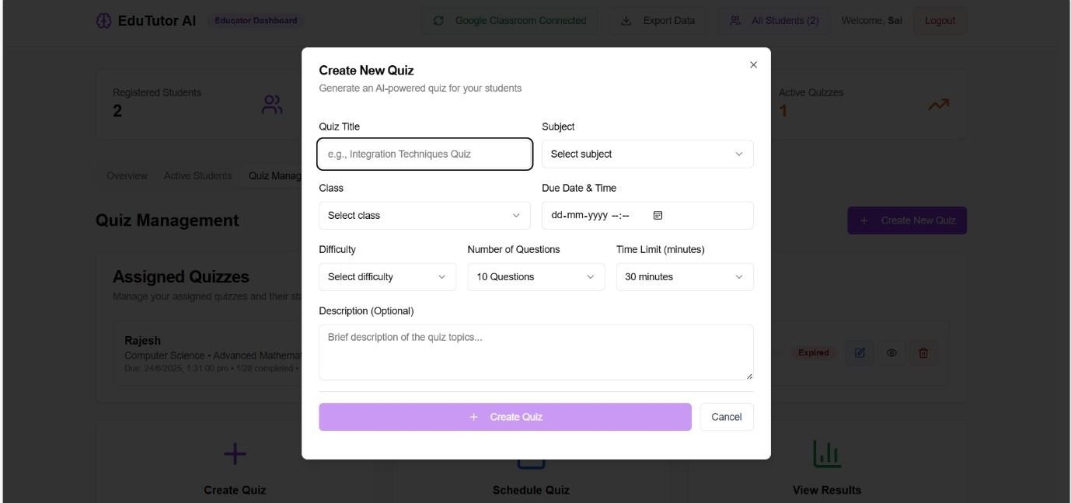

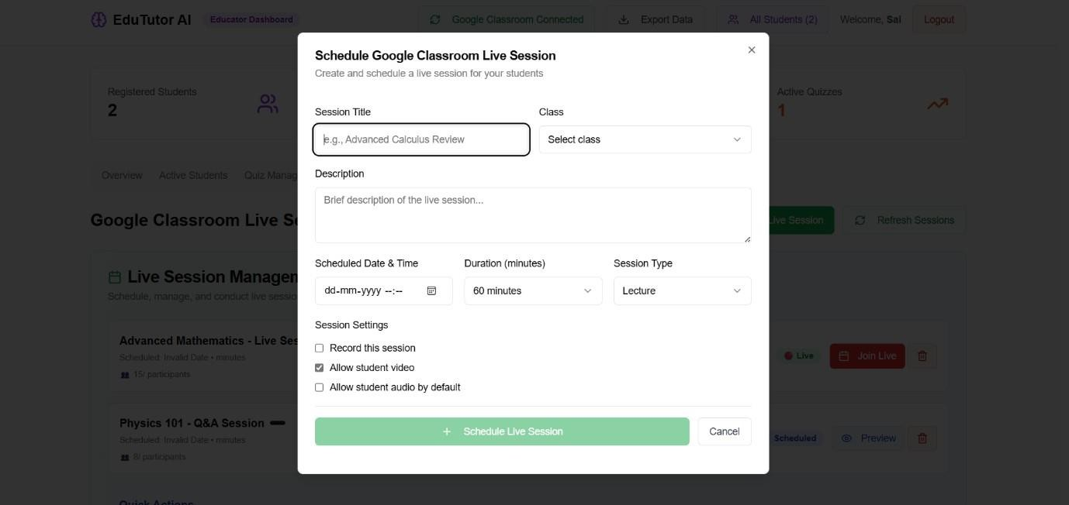

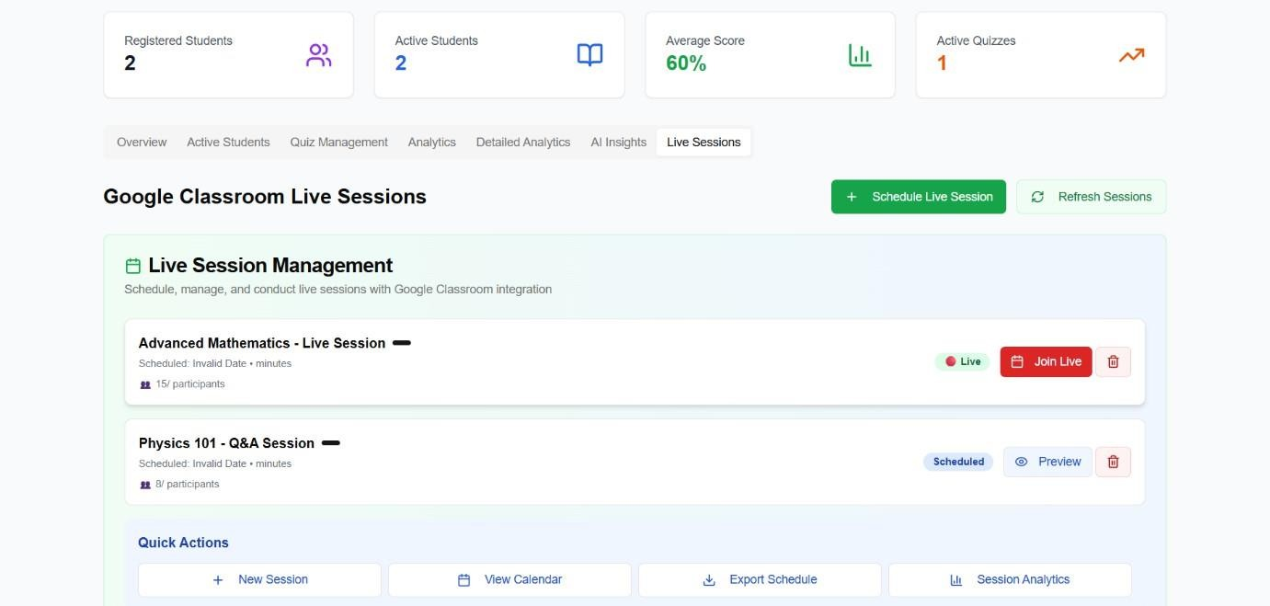

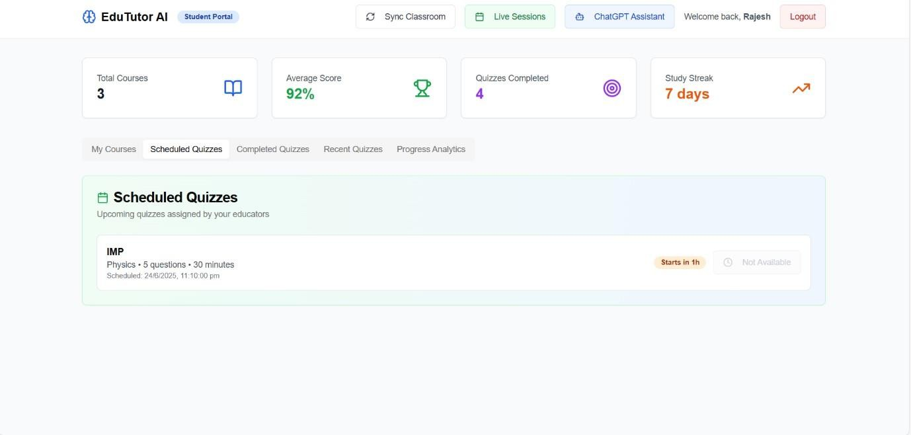

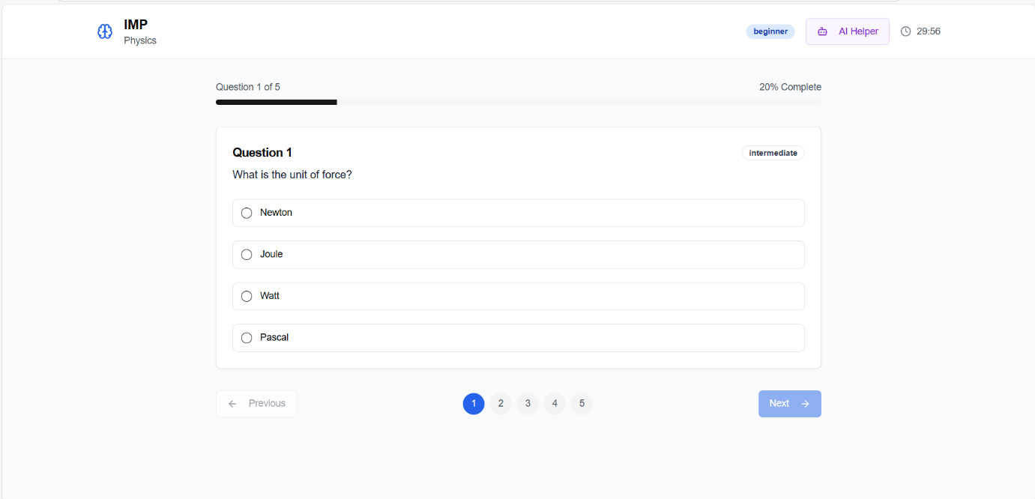

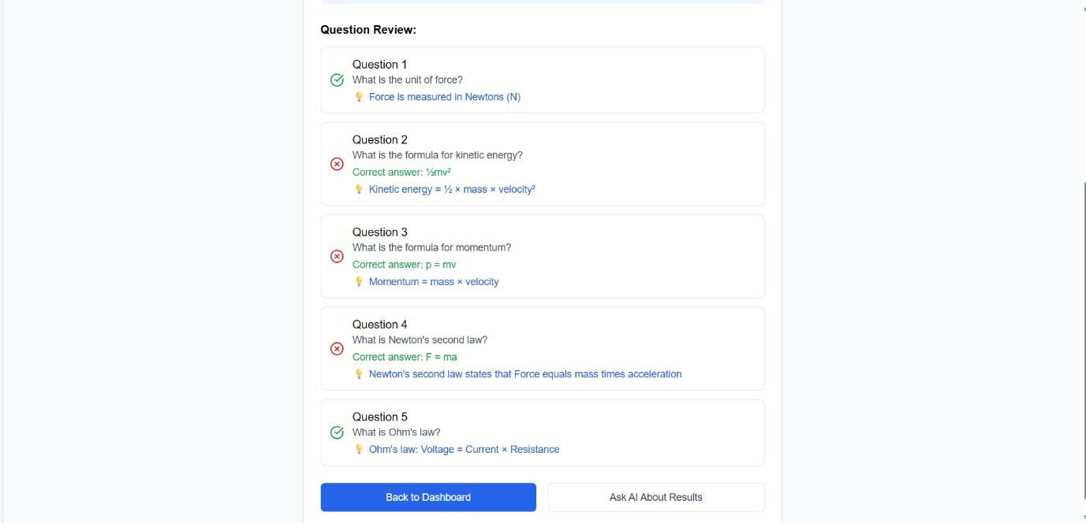

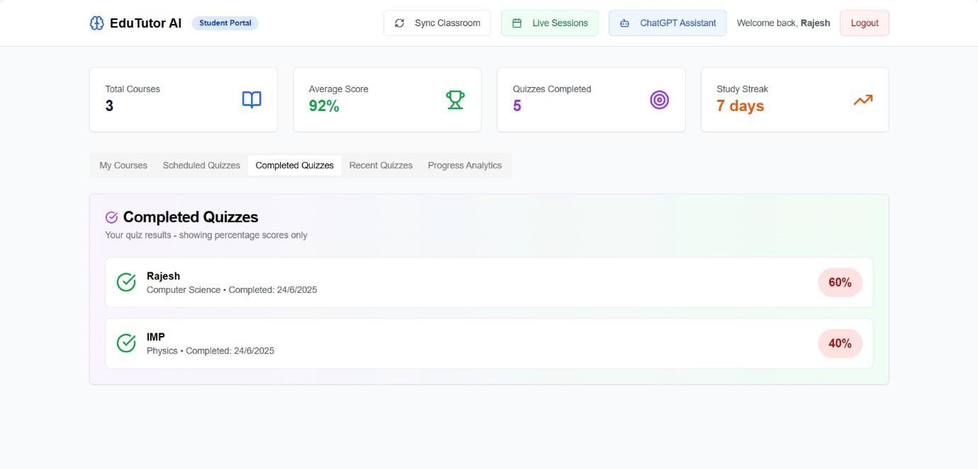

# ADVANTAGES & DISADVANTAGES

## Advantages

* True personalized learning experience
* Seamless LMS integration
* Time-saving for educators
* Real-time performance tracking
* Inclusive (supports voice input)

## Disadvantages

* Requires internet and AI API credit costs
* Initial integration setup time
* Possible inaccuracies from AI content generation
* Voice transcription accuracy depends on audio quality

# CONCLUSION

EduTutor AI leverages cutting-edge generative AI to revolutionize learning. It solves a real- world problem in the education sector by bringing adaptive, intelligent, and accessible tools into familiar LMS platforms. The system is scalable, effective, and supports both student outcomes and instructor efficiency.

# FUTURE SCOPE

* Multilingual learning support using AI translation
* AI-generated video explanations with avatars
* Blockchain for credential tracking
* Integration with wearable tech for attention tracking
* Gamification: XP points, badges, level unlocks
* AI prediction of student drop-off risks

# APPENDIX

* **Source Code**: <https://github.com/22ME1A05C8/EduTutor-AI-Personalized-Learning-with-Generative-AI-and-LMS-Integration.git>
* **Demo Video**: [Screen Recording 2025-06-26 221212.mp4](Screen%20Recording%202025-06-26%20221212.mp4)
* **Website page**: [https://smartskill.vercel.app](https://smartskill.vercel.app/)